Educator’s Resource Guide

Welcome to Janet’s Planet where we are traveling at the speed of thought! This study guide is intended to assist educators as a supplement to our live show, “Janet’s Planet, Tour of the Solar System.” The resources on the following pages are designed to help your students fully grasp the scientific and theatrical concepts they have experienced, and to nourish the seeds of discovery and adventure that we hope to have planted.

VIEW Janet’s TEDx Talk: AWE Inspired Science here:
https://www.youtube.com/watch?v=PP6lEgNbhXk

Janet’s Planet would like to thank you, the educator, for attending our show and want you to know that we are here to serve and are more than willing to do follow up in your classroom via SKYPE. To request a 30-45 minute follow-up SKYPE session, just email us at janet@janetsplanet.com.

We are now using NGSS for all Content Standards and Objectives.

Next Generation Science Standards APP can be found here:

For I-Phone and Apple Users:
https://itunes.apple.com/us/app/next-generation-science-standards/id683491579?mt=8

For Android Users:

https://play.google.com/store/apps/details?id=com.masteryconnect.NGSS&hl=en

“Janet’s Planet Tour of the Solar System “Meets these NGSS AND CC Standards:
NGSS (Next Genera on Science Standards) ESS1-1, ESS1-2, ESS1-3, ESS1-4 CCSS (Common Core State Standards) SL.1.2, SL.2.2, SL.3.2, SL.4.2, SL.5.2

Janet’s Planet Solar System Vocabulary Words

LESSON/ACTIVITY
Students will learn the basics of the solar system and terms used to describe objects in space.
Take students to the playground, gym, or just make some space in your own room and split the students into small (3 or 4) groups. Give each group a vocabulary word and ask them to decide how to explain their vocabulary word. They can talk, draw, act out, etc. - ask them to be creative. Then have groups share their explanations and work together to correct problems in the
definitions, and make sure the entire class understands each concept.
- Asteroid - A small, rocky object that orbits the sun, usually in a band between orbits of Mars and Jupiter
- Asteroid Belt - Region of the solar system that is between the orbits of Mars and Jupiter and in which most asteroids orbit
- Astronomical Unit - Average distance between the Earth and the Sun; approximately 93 million miles. (which equals approximately150 million kilometers)
- Astronomy - The scientific study of stars, planets, and other objects in outer space.
- Astronomer - A scientist who studies the Universe and the objects within it.
- Atmosphere - The gaseous area surrounding a planet or other body
- Black Hole - A region of space around a very small and extremely massive object within which the gravitational field is so strong that not even light can escape.
- Comet - A small, frozen mass of dust and gas revolving around the sun.
- Constellation - A grouping of stars which have been given names by ancient astronomers because of the way they look.
- Eclipse - When our view of one object in the sky is blocked by either another object or the Earth's shadow. (AUGUST 17, 2017 is going to be a TOTAL SOLAR eclipse. Check out its path here: http://www.eclipse2017.org/2017/path_through_the_US.htm)
- Galaxy - A group of stars, gas and dust held together by gravity.
- Gas Giant - A planet that has a deep, massive atmosphere, such as Jupiter, Saturn, Uranus, or Neptune
- Gravity - An invisible pulling force that tends to pull two objects toward each other. The more massive an object is, the stronger its gravitational pull is. Earth's gravity is what keeps you on the ground and what causes objects to fall. Gravity is what holds the planets in orbit around the Sun and what keeps the Moon in orbit around Earth. Gravity is what gives you weight. It is the force that pulls on the mass in your body.
- Local Group - A group of around two dozen galaxies, it is the group to which our galaxy belongs.
- Meteor - A bright streak of light that results when a meteoroid burns up in the Earth's atmosphere.

- Meteorite - A meteoroid that reaches the Earth's surface without burning up, a Meteorite or think of it as an object from Outer Space, such as a rock, that falls into the Earth and lands on its surface.

- Meteoroid - A relatively small, rocky body that travels through space

- Milky Way Galaxy - The Milky Way is the Galaxy in which we live. It is a spiral shaped galaxy that contains several hundred billion stars, including our Sun. It is about 100,000 light-years across and about 10,000 light-years thick.
- NASA - The National Aeronautics and Space Administration
- Orbit - The path that a body follows as it travels around another body in space. The path one object takes around another.
- Nebula - A cloud of gas and dust where stars are born.
- Planet - A planet is an object orbiting a star that is large enough to be rounded by its own gravity. It is also gravitationally dominant in its orbital area but not large enough to cause thermonuclear fusion (like stars do).
- Rotation - Rotation is when a planet or moon turns all the way around or spins on its axis one time. The axis of rotation is an imaginary line going from the North pole to the South pole. On Earth, a rotation is pretty short - it happens once a day!
- Revolution - The motion of a body that travels around another body in space; one complete trip along an orbit.
- Rocket - A machine that uses escaping gas from burning fuel to move
- Rotation - The spin of a body on its axis
- Satellite - A natural or artificial object that revolves around a planet
- Solar Nebula - The cloud of gas and dust that formed our solar system
- Solar System - The system of planets and other objects orbiting the star Sol, which happens to be our Sun.
- Space Probe - An unmanned vehicle that carries scientific instruments into space to collect data.
- Space Station - A long-term orbiting platform from which other vehicles can be launched or scientific research can be carried out
- Star - A self-luminous object that shines through the release of energy produced by nuclear reactions at its core.
- Telescope - Just because you can't see something doesn't mean it isn't there. Sometimes, you just need to look closer. This is where a telescope comes in handy. A telescope is an instrument that's used to look at objects that are far away by gathering light. People generally use telescopes to look at objects in outer space, like planets, stars and comets.
- Terrestrial Planet - One of the highly dense planets closest to the Sun; Mercury, Venus, Earth, and Mars
- Universe - Our universe is a large and unimaginable expanse of dust, gas, stars, clouds, galaxies, and life. If you could look at the entire universe at once it would look like a giant spiderweb, made up of billions of galaxies, and trillions and trillions of stars.

Janet’s Planet Show Description

Janet’s Planet and her JP Space Crew are taking their new friends on an out of this world adventure! Janet, along with Galileo her Super Computer, Cody the Robot, Professor Cosmos and Dr. Comet are going to start at the SUN and share the wonder of our Solar System by visiting every planet orbiting around the star at the center of it all! One young astronaut (a special cadet in training from the audience) will even get to walk on the moon!
On this tour the JP ship’s supercomputer Galileo has been communicating with its friend Voyager 1 currently in deep space, and apparently Voyager 1 saw a star go SUPERNOVA! So the crew is headed to the edge of the solar system for a Super Nova Pizza Picnic. Just as the JP Space Crew is ready to blast off and take a tour of each of the planets in the solar system, the ship’s super computer Galileo malfunctions at the hands of Dr. Comet. Galileo is crucial to the mission because he transmits intergalactic knowledge from his vast hard drives that helps Janet’s Planet maneuver in space. A temporary residence is found for his brilliant mind, TOAST-BOT, the toaster the guys made in college. Cody brings Galileo down from Mission Control to the theatre bay so that the audience and Janet can monitor him. It is now up to the JP Space Crew, Professor Cosmos, Cody the Robot, Dr. Comet, Janet and the audience to gather all the elements necessary to repair Galileo with materials from our very abundant solar system and to race against time to get to the edge of the Solar System to get a glimpse of that SuperNova!
LESSON/ACTIVITY:
Read through the description of the show and the list of planets in the solar system. Talk to students about a mnemonic and how you can use them to help remember lists of things. Teach them the “My Very Excellent Mother Just Served Us Noodles” for the order of planets.
Encourage students (individually or in groups) to come up with their own mnemonic.
http://planetfacts.org/planet-mnemonics/ this is a listing of Mnemonics and gives several examples.

#Dear Pluto
Is Pluto a Planet or a Dwarf Planet?

Read the sections on why Pluto is no longer a planet.
Tell your class that after 76 years in the Solar System that the International Astronomical Union decided that to be a planet a planet meet these 3 criteria:
- A planet must orbit the Sun (Pluto does this!)
- A planet must have HYDROSTATIC EQUILIBRIUM or a NEARLY ROUND SHAPE! (Pluto is ROUND!)
- And a planet must have enough mass to dominate the path in its own orbit, which basically just means that it has to be STRONG ENOUGH to maintain its orbit regardless of what is in its path. (Pluto doesn’t survive criteria #3. There are objects in its orbit larger than it is and Pluto has a tendency just to go around that larger object, and therefore Pluto’s orbit is a tad irregular. Dr. Alan Stern that if EARTH were out some 3 billion miles away from the sun, Earth’s orbit would be irregular. Which makes him argue that anything that orbits the sun, regardless of size or mass, that isn’t a star and going through nuclear fusion, should be considered a planet)
http://missionscience.nasa.gov/nasascience/what_is_a_planet.html The criteria for what is a planet and why Pluto is classified as a dwarf planet.
http://www.iau.org/public/themes/pluto/ The International Astronomical Union (IAU) which works to identify and describe the objects in our sky.
Watch The Janet’s Planet Official YouTube Channel to view
The Adventures of Pluto Series: https://www.youtube.com/watch?v=6bYDqsUQPPw&list=PLP7Opo_BK7OqyN8ismIXsNVdevprBTTLD
Consider submitting your classes #DearPluto letters and let them write to Pluto and tell Pluto what they think the New Horizons mission may discover as they go through all the data that the unmanned spacecraft recorded on its flyby July 14, 2015.

In honor of NASA’s New Horizons Mission to Pluto, Janet’s Planet is inviting you (and everyone you know) to share your hopes, your ideas, your thoughts, your beliefs and planetary wisdom in a written or video letter to Pluto, that beloved little planet that is 3 billion miles away from our Sun! It all starts with just two little words: #Dear Pluto! We can’t wait to see what you have to say.
See what your students would like to ask Pluto?
ASK: What would you ask Pluto if you had the opportunity? Maybe how cold it is out in the Kuiper Belt? Whether it’s lonely out there?
Whatever your students have to say, we’d love to know and you can submit your written letter with your own drawing of Pluto to Janet and the JP Space Crew! Just scan in your classroom letters and send to janet@janetsplanet.com or snail mail them to: Janet’s Planet, 242 West Main Street, #214, Hendersonville, TN 37075

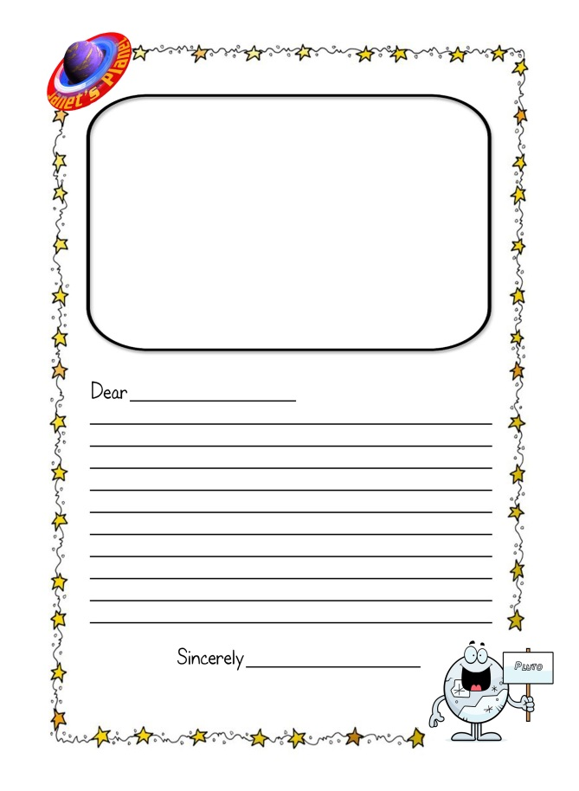
Download the template at: http://janetsplanet.org/dear-pluto/
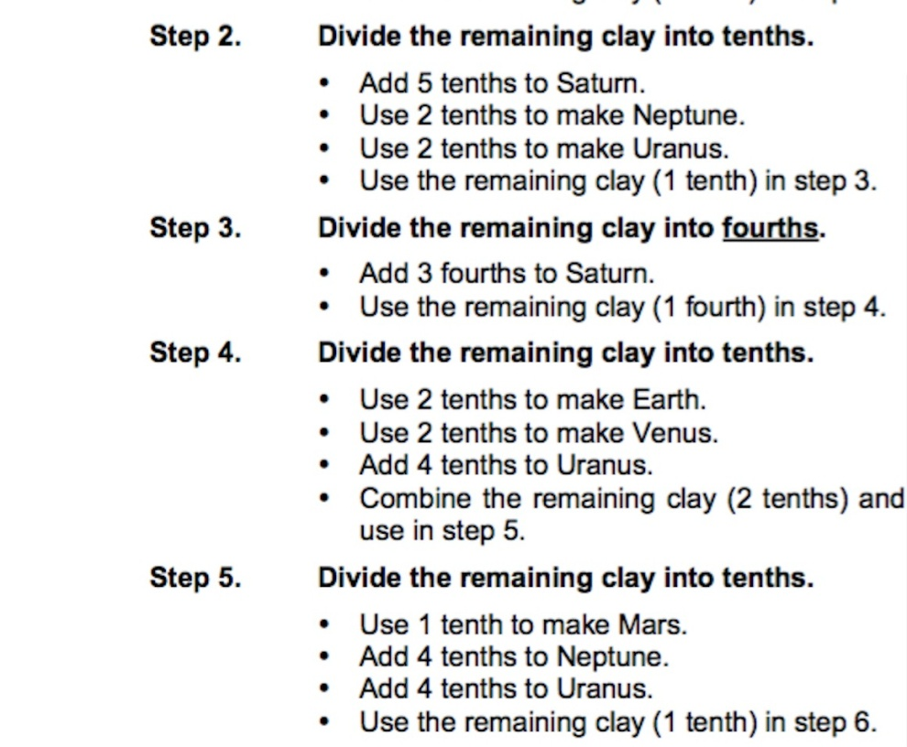
Scale Model of the Solar System
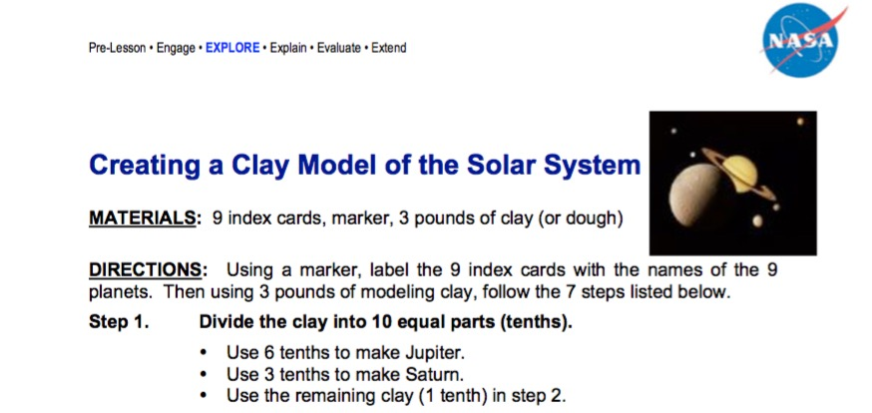

5-10 lb. ball of play dough

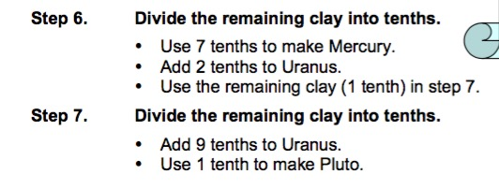

LESSONS LEARNED
I personally like to use anywhere from a 5 lb. to 10 lb. ball of PlayDoh so that the students have enough dough to create the scale of the solar system. Clay is very hard to work with and play dough is much easier to divide with hands and plastic knifes. (I just weigh it on my home bathroom scales to make sure I have the amount I want.)

Also, you can use scales in the classroom to get the students to really get a sense of what 10 EQUAL parts looks like, and to be exacting like a scientist! You CHOOSE!

The original NASA lesson plan calls for a 3 lb ball of clay, I greatly encourage you to do at least
5 - 10 lbs. of dough. It creates a much better scale model and illustration of the difference in the sizes of the planets. FULL NASA SOLAR SYSTEM MATH PDF found here: https://www.nasa.gov/pdf/622144main_SSML1Stdnt.pdf

I highly advise working with Play Doh rather than Clay (Dollar Store cheapest Variety is fine) or make your own!

Here is my recipe for home-made Play-Doh:
Ingredients: (I usually triple the ingredients below, it just depends on the amount you
want to make. I also think you can use essential oils to make it smell great, lavender, peppermint or lemon, and you can even use DRY Kool Aid to color the PlayDoh if you are worried about someone being allergic to food coloring.
If you only start with these ingredients, this recipe below will make you a large ball of PlayDoh. I usually make it repeatedly for however many colors I want (so if you want 6 big balls, know that you will need 6 times the ingredients listed above, but you will need to make them separately). I usually triple the recipe from the start and that will yield about 2-3 lbs. of dough.

1 cup flour
1 cup water
2 tsp. cream of tarter
1/3 cup salt
1 TBS vegetable oil
Food coloring or you can use Dry Koolaid and knead in the color

Instructions:
- Mix together all the ingredients, except the food coloring, in a medium saucepan.
- Cook over low/medium heat, stirring. Once it begins to thicken, add the food coloring.
- Continue stirring until the mixture is much thicker and begins to gather around the spoon
- Once the dough is not wet, remove and put onto wax paper or a plate to cool.
- After cooling (30 minutes) knead PlayDoh for a few seconds.

REFLECTIONS

Watch To Scale: The Solar System
Watch a team of friends create a scale of the distances
between the planets using 7 miles of desert. https://www.youtube.com/watch?v=zR3Igc3Rhfg

Follow up questions:

After making a scale model of the Solar System with PlayDoh…

- Who thought that EARTH was a lot bigger than it is?

- Who thought that Mars was smaller than Earth?

- After seeing how tiny Pluto is to scale, what do you think? Is it a planet? Is it just a dwarf planet?

Toilet Paper Solar System
Adapted by Suzanne Chippindale. Based on an idea by the late Gerald Mallon © Copyright 2001, Project ASTROTM, Astronomical Society of the Pacific
An ASTRO Activity from the Astronomical Society of the Pacific
- Recommended for Ages: 6 and up
- Time to do: 20 minutes
- Type of Activity: Facilitated
- Number of People: 1-4 per model
- Set-up Time: 3minutes
What’s This About?
Even in our own “cosmic neighborhood,” distances in space are so vast that they are difficult to imagine. In this activity, participants will build a scale model of the distances in the solar system using a roll of toilet paper. This is a great follow-up to the Create a Scale Model of the Solar System with Playdoh activity, where students get a sense of the relative sizes of the planets.
Materials Included (At end of Lesson Plan)
- Table of distances to give to students: Two to choose from. The longer [200 sheets] requires 85 feet and the shorter [100 sheets] requires 42 feet of space.
- Materials You’ll Need to Get:
▪ One roll of toilet paper, 201 sheets or more, per team of students.
▪ Crayons, Felt-tip marker(s) or gel pens, preferably 10 colors; but one pen per team will do.
▪ Clear tape for repairs
Setting up the Activity:
▪ Select either the 200 or 100 sheet model and photocopy the handout.
▪ Pass out pens, table of distances, tape dispenser and roll of toilet paper to each team.
Suggestions for Introducing the Activity:
Representing both the sizes of the planets and the distances between them with the same model is very difficult unless you have 1000 yards to work with. This model only shows the relative distances between the planets and still requires approximately 85 feet to complete (in the longer scale on the next page).
If you have just completed the Scale Model of the Solar System activity remind students that this is the RELATIVE distance between the planets.
Be sure to share the Scale Model of the Solar System here on YouTube:
https://www.youtube.com/watch?v=zR3Igc3Rhfg
And also share with the students that because of the elliptical nature of the planets orbits that the planets will never all be in a straight line going out from Sun, as they are represented in this model.
Doing the Activity:
Take one sheet of toilet paper as a test sheet for the pens. Make sure the ink is not too wet, that the pens don’t easily tear the paper. Also, have students practice writing on the delicate paper with one test sheet. After they have learned the best way to write on toilet paper, throw away the test sheet.
Suggest they make a dot on the seam between the first two sheets of toilet paper. This is the Sun. Write the word Sun beside the dot.
Then they can use the table of numbers provided to mark off the distances to each of the planets. The number in the table is the number of sheets of toilet paper needed to reach the orbit of each planet. It is important to tell students that the counts in the table are starting from the Sun, not from the previous planet. (Thus, after you get to Mercury, you need 1.7 more sheets to get to Venus.) They should make a dot and write the appropriate planet name on the toilet paper at the distance indicated. Ceres, the largest asteroid, is used to represent the asteroid belt.
If you don’t have the time or space to complete the model, try to get to Jupiter and note that Saturn nearly doubles the distance. The same is true of going from Saturn to Uranus. Or, try using the short version of the scale in the third column below (Note that we have included two handouts, one for each version).
Toss the toilet paper in recycling to clean up.
Lessons Learned
Pen Tips: If pens are very liquid they may bleed through too much or tear the paper. Gel pens work well.
Toilet Paper Tips: Cheap, flat toilet paper generally works best. Textured paper is okay; printed paper can be distracting.
For Younger Students Beginning to Count: It is ENTIRELY FINE to round up or down to facilitate this with K-2 graders.

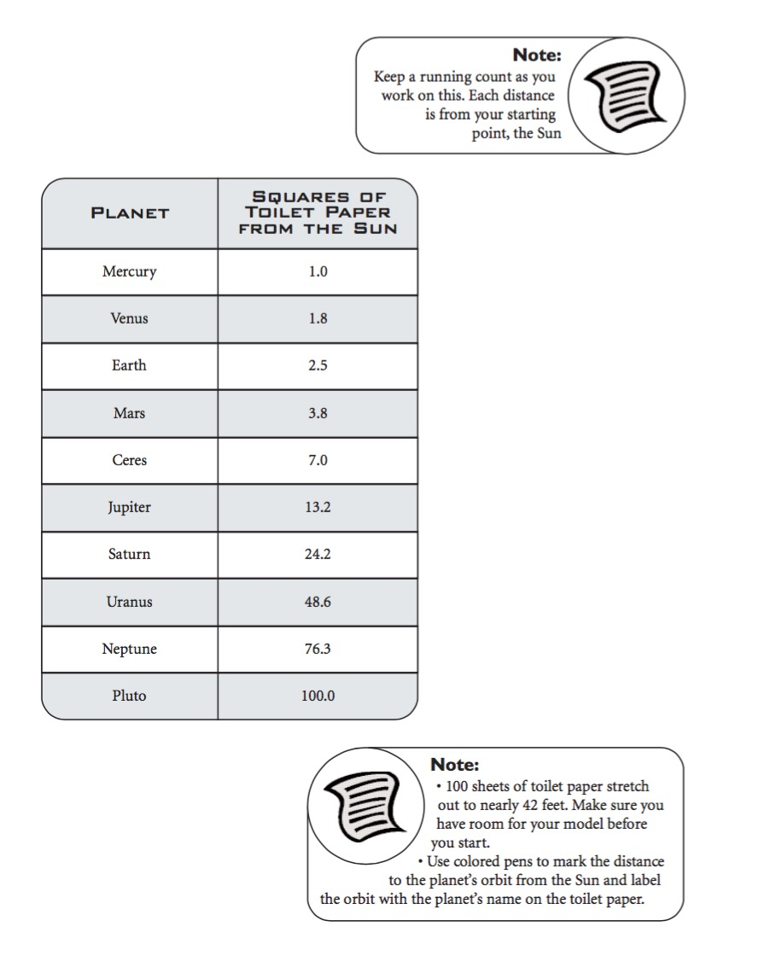
100 Sheet Version:
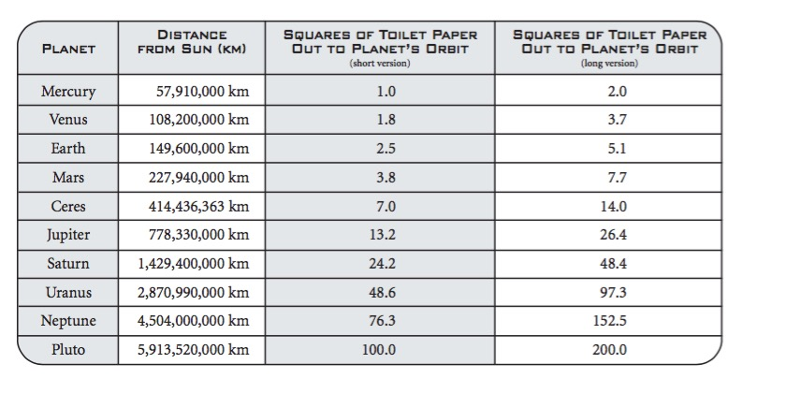

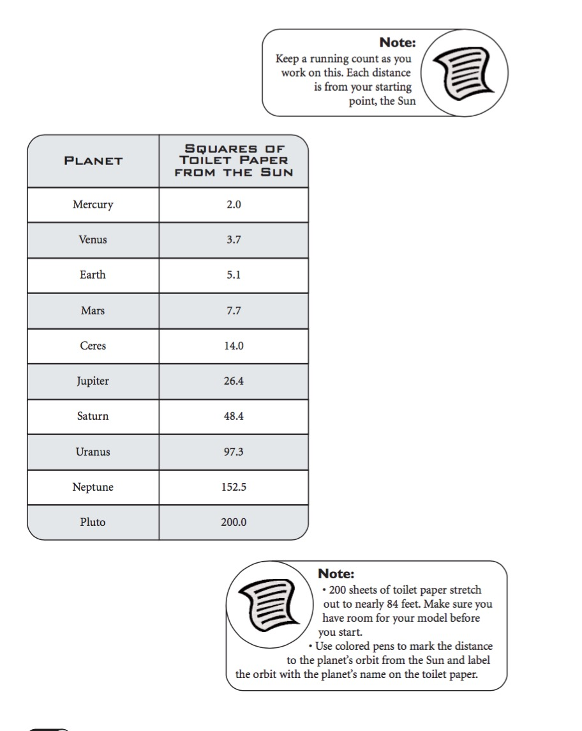
200 Sheet Version:
Dance Your Solar System
Invent a “solar system dance.” Study how the planets behave in their orbits. Choose as many celestial bodies as you have students in class. Those bodies can be the planets, dwarf planets, stars, comets, satellites, etc. Have students decide what to hold/make to represent the celestial body [eg., a picture, a tail (for a comet), a hula hoop (for Saturn)]. Have students research where they belong in the Solar System and also how they might move in their revolutions and in their rotations. Have students practice moving with each other and creating a living model of the solar system.
Choose Music from “The Planets” by Gustav Holst to play during the students dance and interpretation of rotation, revolution, and planetary orbits.
http://www.windows2universe.org/ Site with interactive identification of celestial bodies.Students will explore the music “The Planets” by Gustav Holst and also the way sound waves work.
http://www.gustavholst.info/ Official site for Gustav Holst
Each movement of music in The Planets.
http://www.youtube.com/watch?v=L0bcRCCg01I Mars
http://www.youtube.com/watch?v=EE6_PacCnRw Venus
http://www.youtube.com/watch?v=RkiiAloL6aE Mercury
http://www.youtube.com/watch?v=Gu77Vtja30c Jupiter
http://www.youtube.com/watch?v=MO5sB56rfzA Saturn
http://www.youtube.com/watch?v=aDFGmiXnLjU Uranus
http://www.youtube.com/watch?v=rErPKeZmn5w Neptune
FACT: Gustav Holst wrote the music about the planets before a picture of Mercury had ever been taken.
EXPLORATION: Could you write a song about a planet? Would it just be music? Or would your song about a planet have lyrics too?
Listen to Janet’s Planet song about the planets here: Zoom Zoom Zoom. https://itunes.apple.com/nz/album/janets-planet/id268385695

Internet Resources
https://www.google.com/#newwindow=1&q=solar+system+webquest list of web quests
http://solarsystem.nasa.gov/kids/ NASA kids site
http://spaceplace.nasa.gov/menu/solar-system/ NASA solar system
http://www.nasa.gov/audience/forkids/kidsclub/flash/ NASA space games
http://kids.nationalgeographic.com/kids/games/actiongames/plutos-secret/ Game that goes to discover the reason Pluto is no longer a planet. Not easy, but students might enjoy it.
http://solarsystem.nasa.gov/yss/index.cfm Year of the Solar System activities
http://mel.ess.ucla.edu/jlm/epo/planet/planet.html What is a planet?
http://www.infoplease.com/spot/pluto-demoted.html Information for pluto.
http://www.iau.org/public/themes/pluto/ Definitions of planets and other celestial bodies
http://spaceplace.nasa.gov/chandra.htm NASA spaceplace for kids
Play an online game! Protect the planets from incoming asteroids!
https://quizlet.com/5441591/gravity
http://www.discoveryeducation.com/search/page/-/-/-/-/index.cfm?Ntx=mode+matchallpartial&Ntk=all-prelogin&Ne=4294967203&Nr=OR(OR(d_Index_Type:Pre-login),OR(d_Domain:www.fit4theclassroom.com))&N=4294967203+31&Ntt=space

Reading Materials

Planet Name Game (Dr. Seuss/Cat in the Hat -- Step into Reading) by Tish Rabe, Random House Books for Young Readers (January 6, 2015), Grades K-1

You Are the First Kids on Mars by Patrick O'Brien, G.P. Putnam's Sons Books for Young Readers (May 12, 2009), Grades K-3

The Planets in Our Solar System (Let's-Read-and-Find-Out Science, by Franklyn M. Branley (Author), Kevin O'Malley (Illustrator), HarperCollins; Reissue edition (August 4, 2015), Grades K-2
Zoo in the Sky: A Book of Animal Constellations, by Jacqueline Mitton & Christina Balit, National Geographic Children's Books; Reprint edition (October 24, 2006), Grades K-3

I Want to Be an Astronaut by Byron Barton, HarperCollins; Reprint edition (February 28, 1992), Grades K-3
Postcards from Pluto: A Tour of the Solar System by Loreen Leedy, Publisher: Holiday House; Revised edition (July 15, 2006), Grades 1-3

National Geographic Reader: Planets by Elizabeth Carney, National Geographic Children's Books (July 10, 2012), Grades 2-4
Our Solar System by Seymour Simon (Smithsonian), Grades 3-6
The Latest View of the Solar System, (National Geographic Kids), by David Aguilar, Grades 4-6

Child's Introduction to the Night Sky: The Story of the Stars, Planets, and Constellations--and How You Can Find Them in the Sky, by Michael Driscoll (Author), Meredith Hamilton (Author), Black Dog & Leventhal; Stk edition (May 1, 2004), Grades 4-6

Destination: Space by Seymour Simon, HarperCollins; Revised ed. edition (May 23, 2006), Grades 4-7
Exploring the Solar System: A History with 22 Activities by Mary Kay Carson, Chicago Review Press; Revised edition edition (February 1, 2008), Grades 5-8

Almost Astronauts: 13 Women Who Dared to Dream, by Tanya Lee Stone, Candlewick Press, 2009, Grade 5-8
Astrophysics is Easy!: An Introduction for the Amateur Astronomer by Michael D. Inglis, Springer; 2 edition (December 4, 2014)
The Backyard Astronomer’s Guide by Terence Dickinson and Alan Dyer, Firefly Books; Enlarged 3rd edition (September 12, 2008)
Space: From Earth to the Edge of the Universe by Carole Stott, Robert Dinwiddie, David Hughes and Giles Sparrow, DK Publishing (October 4, 2010)
Wonders of the Universe by Brian Cox and Andrew Cohen, Harper Design (October 4, 2011)

